Business Model:

We target the public sector of the government.

In theory, all sorts of information, from birth records to business transactions, can be baked into a blockchain, creating permanent and secure records which cannot be tampered with, for instance by corrupt officials.

And integrating databases across vast and complex bureaucracies will need huge investment.

The movement called digital india is the first step forward for the above two points. With the support of the government and its initiative we will take the cumbersome tasks of integrating databases and digitsing transaction.

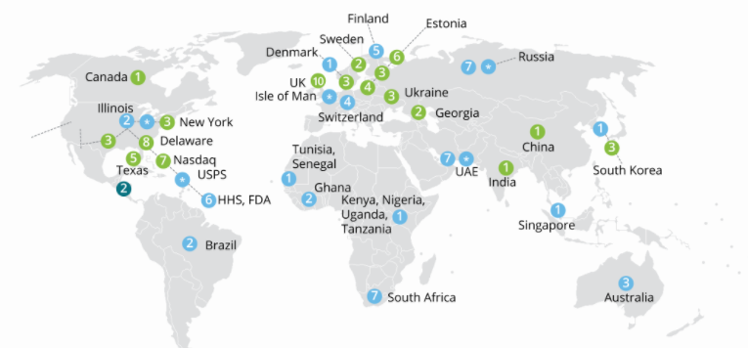

Countries which implemented blockchain-green

Considering it-blue

Announced- sky blue